CHAPTER 9
ESTIMATION FROM SAMPLE DATA

SECTION EXERCISES
9.1 d/p/e A point estimate is a single number that estimates the value of the population parameter,
while an interval estimate includes a range of possible values which are likely to include the population parameter.

9.2 d/p/e Inferential statistics is when we use sample information to draw conclusions about the
population. We can use the sample information to estimate the population parameter.

9.3 d/p/m When the interval estimate is associated with a degree of confidence that it actually includes the population parameter, it is referred to as a confidence interval.

9.4 d/p/m A sample statistic is an "unbiased estimator" if the expected value of the sample statistic is the same as the actual value of the population parameter it is intended to estimate.

9.5 d/p/m In order for s² to be an unbiased estimator of σ², we must use (n - 1) as the divisor when we calculate the variance of the sample. However, s will not be an unbiased estimator of σ.

9.6 d/p/m This is a point estimate, since p = 0.38 is a single number that estimates the value of the
population parameter, π = the true proportion who vacation out of state for at least one week.

9.7 c/a/m
a. 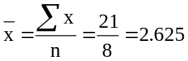 b. 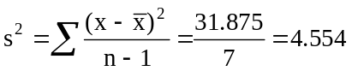

9.8 d/p/d Both of these values could be considered point estimates since they are single numbers that
estimate the value of the population parameter, μ = the population average annual U.S. per capita consumption of iceberg lettuce. The difference between the two consumption figures could not be considered an interval estimate since the two point estimates come from different years.

9.9 d/p/e The accuracy of a point estimate is the difference between the observed sample statistic and
the actual value of the population parameter being estimated.

9.10 d/p/m A key consideration in determining whether or not to use the standard normal distribution in constructing the confidence interval for the population mean is whether or not we know the actual value of the population standard deviation, σ. If σ is known, we will use the standard normal distribution. Otherwise, we will use the t distribution.

9.11 c/a/m
a. point estimate of π: 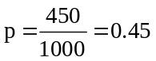 b. confidence interval for π: 0.419 to 0.481
c. confidence level: 95%; confidence coefficient: 0.95
d. accuracy: for 95% of such intervals, the sample proportion would not differ from the actual population proportion by more than (0.481 - 0.419)/2 = 0.031.

9.12 d/p/m If the population cannot be assumed to be normally distributed, when the sample size is at least 30 we can apply the central limit theorem in order for the sampling distribution of the sample mean to be approximately normal.

9.13 d/p/m In this case, we need to assume that the population is normally distributed and the population standard deviation is known.
9.14 c/a/m First, compute the mean of the sample. 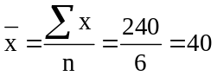
a. For a confidence level of 95%, z = 1.96. (In the normal distribution, 95% of the area falls between
z = -1.96 and z = 1.96.) The 95% confidence interval for μ is:
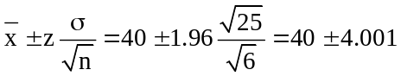, or between 35.999 and 44.001.
We have 95% confidence that the population mean is between 35.999 and 44.001.
b. For a confidence level of 99%, z = 2.58. (In the normal distribution, 99% of the area falls between
z = -2.58 and z = 2.58.) The 99% confidence interval for μ is:
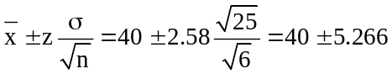, or between 34.734 and 45.266.
We have 99% confidence that the population mean is between 34.734 and 45.266.

9.15 c/a/m
a. For a confidence level of 90%, z = 1.645. (In the normal distribution, 90% of the area falls between
z = -1.645 and z = 1.645.) The 90% confidence interval for μ is:
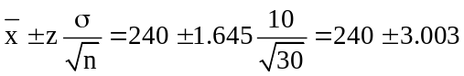, or between 236.997 and 243.003
b. For a confidence level of 95%, z = 1.96. (In the normal distribution, 95% of the area falls between
z = -1.96 and z = 1.96.) The 95% confidence interval for μ is:
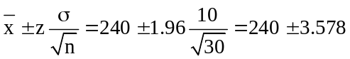, or between 236.422 and 243.578
We could also obtain these confidence intervals by using Excel worksheet template tmzint. Just enter the values for (240), n (30), σ (0.10), and the confidence level desired (0.90 for 90%, 0.95 for 95%). Excel provides the lower and upper confidence limits:
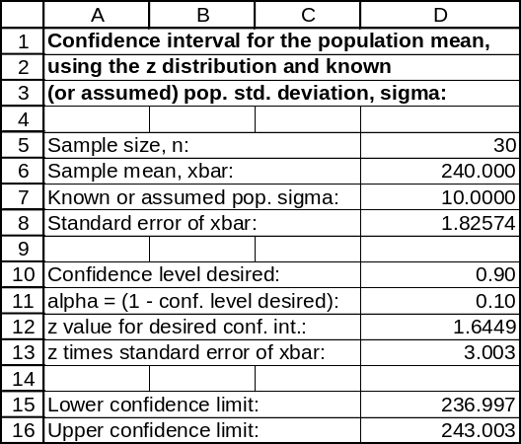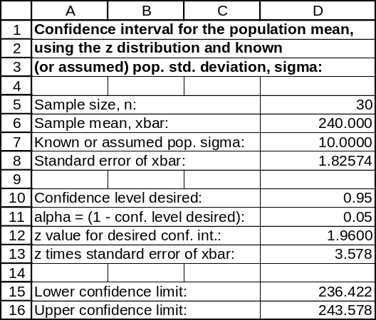

9.16 c/a/m
a. For a confidence level of 95%, z = 1.96. The 95% confidence interval for μ is:
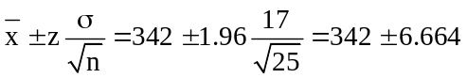, or between 335.336 and 348.664
b. For a confidence level of 99%, z = 2.58. The 99% confidence interval for μ is:
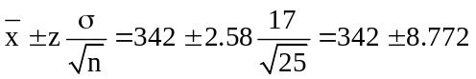, or between 333.228 and 350.772

9.17 p/a/m Using Minitab:
One-Sample Z: score
The assumed sigma = 4
Variable N Mean StDev SE Mean 90.0% CI
score 10 85.00 14.79 1.26 ( 82.92, 87.08)

One-Sample Z: score
The assumed sigma = 4

Variable N Mean StDev SE Mean 95.0% CI
score 10 85.00 14.79 1.26 ( 82.52, 87.48)

9.18 p/a/m Using summary statistics and Excel template tmzint:
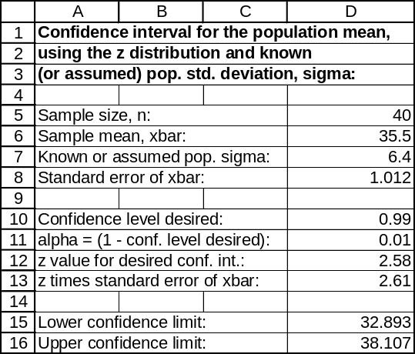

9.19 p/a/m For a confidence level of 95%, z = 1.96. The 95% confidence interval for μ is:
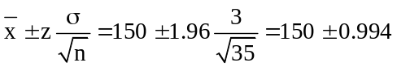, or between 149.006 and 150.994
The confidence level is 95% that the population average torque being applied during the assembly process is between 149.006 and 150.994 lbs.-ft.

9.20 p/a/m For a confidence level of 95%, z = 1.96. The 95% confidence interval for μ is:
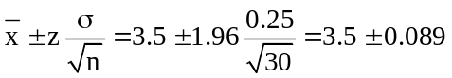, or between 3.411 and 3.589
We could also obtain this confidence interval by using Excel worksheet template tmzint. Just enter the values for (3.5), n (30), σ (0.25), and the confidence level desired (0.95 for 95%), and Excel provides the lower and upper confidence limits:
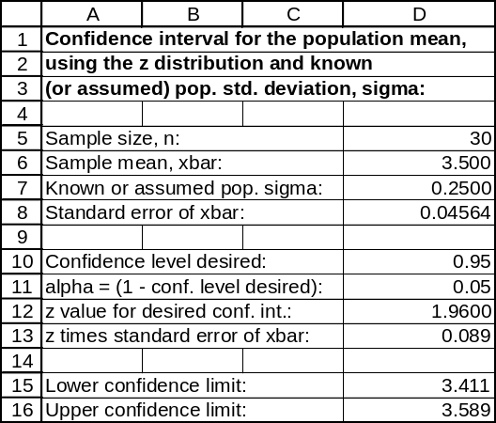

9.21 d/p/m If the sample size had been n = 5, the central limit theorem would not apply. Therefore, in order for the sampling distribution of the sample mean to be approximately normally distributed, we would have to assume that the population is normally distributed.

9.22 p/c/m Using Data Analysis Plus, the data file for this exercise, and the specified value for
σ (2.5 minutes), the 95% confidence interval for the population mean is shown as from 36.282 to 37.261 minutes. The 35.0 minutes value is not within this interval, so the mean time for the task may have changed.
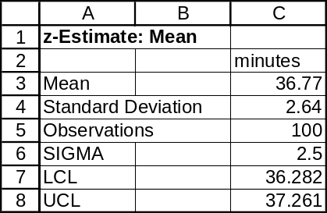

9.23 p/c/m Using Data Analysis Plus, the data file for this exercise, and the specified value for
σ (0.25 fluid ounces), the 90% confidence interval for the population mean is shown as from 99.897 to 100.027. The 100.0 fluid ounces value is within this interval, so the mean content could be 100.0 fluid ounces. Also shown is the corresponding Minitab printout.
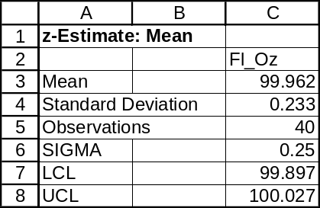

One-Sample Z: Fl_Oz
The assumed sigma = 0.25
Variable N Mean StDev SE Mean 90.0% CI
Fl_Oz 40 99.9618 0.2325 0.0395 ( 99.8967,100.0268)

9.24 d/p/e When n < 30, we must assume that the population is approximately normally distributed.

9.25 d/p/e As the sample size increases, the t distribution converges on the standard normal distribution. The two distributions are identical as the sample size approaches infinity.

9.26 c/p/e Referring to the 0.025 column and the d.f. = 19 row of the t table, the value of t corresponding to an upper tail area of 0.025 is t = 2.093.

9.27 c/p/e Referring to the 0.10 column and the d.f. = 28 row of the t table, the value of t corresponding to an upper tail area of 0.10 is t = 1.313.

9.28 c/a/m For d.f. = 25:
a. P(t ≥ A) = 0.025. From the 0.025 column and the d.f. = 25 row of the t table, A = 2.060.
b. P(t ≤ A) = 0.10. Referring to the 0.10 column and the d.f. = 25 row of the t table, the value of t corresponding to a right-tail area of 0.10 is t = 1.316. Since the curve is symmetrical, the value of t for a left-tail area of 0.10 is A = -1.316.
c. P(-A ≤ t ≤ A) = 0.99. In this case, each tail will have an area of (1 - 0.99)/2 = 0.005. Referring to the 0.005 column and the d.f. = 25 row of the t table, A = 2.787.

9.29 c/a/m For d.f. = 85:
a. P(t ≥ A) = 0.10. Referring to the 0.10 column and the d.f. = 85 row of the t table, A = 1.292.
b. P(t ≤ A) = 0.025. Referring to the 0.025 column and the d.f. = 85 row of the t table, the value of t corresponding to a right-tail area of 0.025 is t = 1.988. Since the curve is symmetrical, the value of t for a left-tail area of 0.025 is A = -1.988.
c. P(-A ≤ t ≤ A) = 0.98. In this case, each tail will have an area of (1 - 0.98)/2 = 0.01. Referring to the 0.01 column and the d.f. = 85 row of the t table, A = 2.371.

9.30 c/a/m First, compute the sample mean and standard deviation: 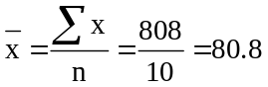
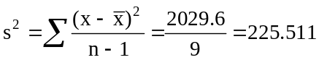, and 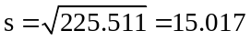
a. For a confidence level of 90%, the right-tail area of interest is (1 - 0.90)/2 = 0.05 with d.f. = n - 1
= 10 - 1 = 9. Referring to the 0.05 column and the d.f. = 9 row of the t table, t = 1.833.
The 90% confidence interval for μ is: 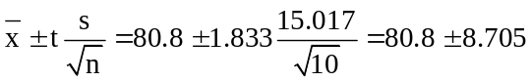,
or between 72.095 and 89.505.
b. For a confidence level of 95%, the right-tail area of interest is (1 - 0.95)/2 = 0.025 with d.f. = 9. Referring to the 0.025 column and the d.f. = 9 row of the t table, t = 2.262. The 95% confidence interval for μ is: 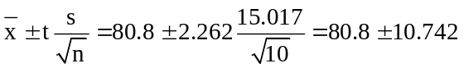, or between 70.058 and 91.542.
We could also obtain the confidence intervals in parts (a) and (b) by using Excel worksheet template tmtint. Just enter the sample size, the sample mean, and the standard deviation values, then enter the confidence level desired (0.90 for 90%, 0.95 for 95%). Excel provides the lower and upper confidence limits. (Note: The results may differ very slightly because our formula calculations rely on the t values in our t table, which are rounded to three decimal places.)
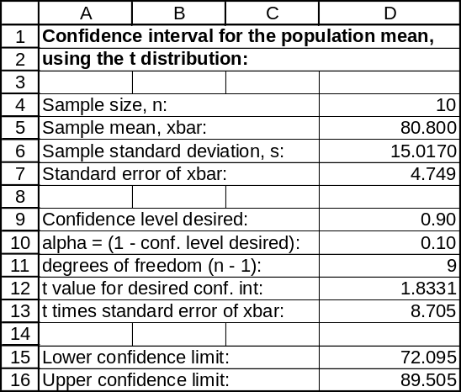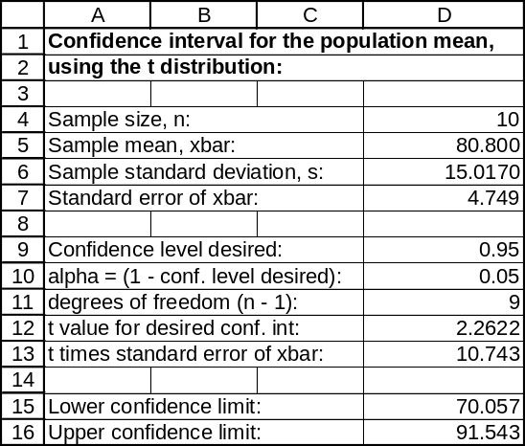

Shown below are Minitab printouts with the 90% and 95% confidence intervals for the population mean.

One-Sample T: x
Variable N Mean StDev SE Mean 90.0% CI
x 10 80.80 15.02 4.75 ( 72.09, 89.51)

One-Sample T: x
Variable N Mean StDev SE Mean 95.0% CI
x 10 80.80 15.02 4.75 ( 70.06, 91.54)

9.31 c/a/m First, compute the sample mean and standard deviation: 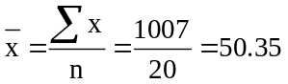
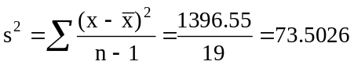, and 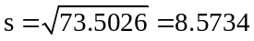
a. For a confidence level of 95%, the right-tail area of interest is (1 - 0.95)/2 = 0.025 with
d.f. = n - 1 = 20 - 1 = 19. From the 0.025 column and the d.f. = 19 row of the t table, t = 2.093.
The 95% confidence interval for μ is: 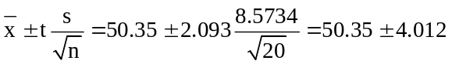,
or between 46.338 and 54.362.
b. For a confidence level of 99%, the right-tail area of interest is (1 - 0.99)/2 = 0.005 with d.f. = 19. Referring to the 0.005 column and the d.f. = 19 row of the t table, t = 2.861. The 99% confidence interval for μ is: 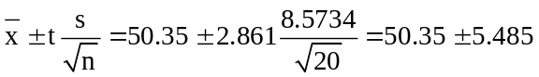, or from 44.865 to 55.835.

Shown below are Minitab printouts with the 95% and 99% confidence intervals for the population mean.

One-Sample T: x
Variable N Mean StDev SE Mean 95.0% CI
x 20 50.35 8.57 1.92 ( 46.34, 54.36)

One-Sample T: x
Variable N Mean StDev SE Mean 99.0% CI
x 20 50.35 8.57 1.92 ( 44.87, 55.83)

9.32 p/a/m
a. For a confidence level of 95%, the right-tail area of interest is (1 - 0.95)/2 = 0.025 with
d.f. = n - 1 = 33 - 1 = 32. Referring to the 0.025 column and the d.f. = 32 row of the t table, t = 2.037.
The 95% confidence interval for μ is: 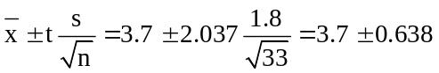,
or between 3.062 and 4.338.
b. For a confidence level of 95%, z = 1.96 (in the standard normal distribution, 95% of the area is between z = -1.96 and z = 1.96). The 95% confidence interval for μ is:
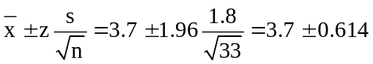, or between 3.086 and 4.314.
c. If σ is not known, the t distribution should be used in constructing a 95% confidence interval for μ. Therefore, the confidence interval found in part a is the correct one.

9.33 p/a/m Given n = 50, = 25, and s = 10, d.f. = n - 1 = 49.
a. The 95% confidence level for μ is: 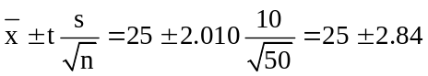, or 22.16 to 27.84.
Using Excel worksheet template tmtint, we obtain a comparable result:
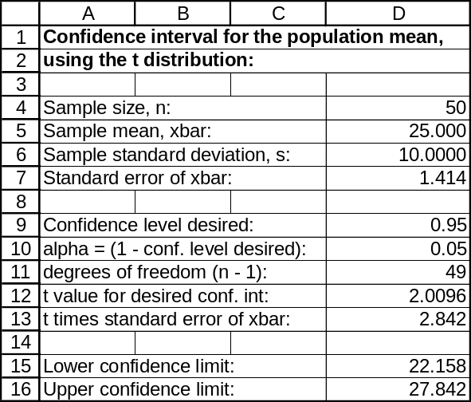

b. The interval constructed in part (a) would still be appropriate, as the distribution of the sample means approximates a t-distribution regardless of the distribution of the original population.

9.34 p/a/m Given n = 20, and using the appropriate formulas for and s, we find the following.
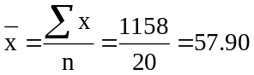, 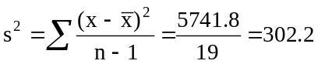 , and s = 17.38
With d.f. = 19, the 90% confidence interval for μ is: 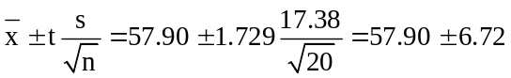
or between 51.18 and 64.62 thousand miles. Shown below is the Minitab 90% confidence interval for the mean.

One-Sample T: miles
Variable N Mean StDev SE Mean 90.0% CI
miles 20 57.90 17.38 3.89 ( 51.18, 64.62)

9.35 p/a/m Using Minitab:

One-Sample T: amps
Variable N Mean StDev SE Mean 95.0% CI
amps 16 29.131 1.080 0.270 ( 28.556, 29.707)

We are 95% confident that the population mean amperage is within the interval shown above.

9.36 p/a/m Using the Excel tmtint template:
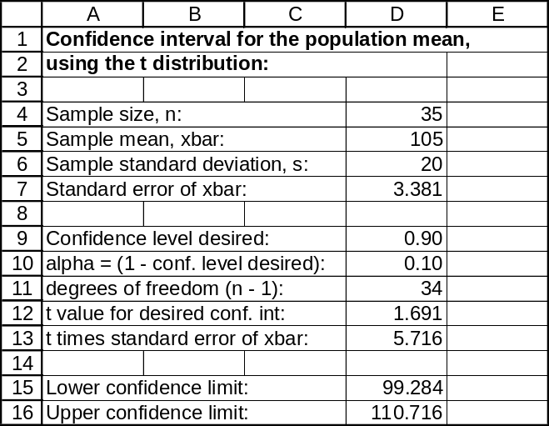

We are 90% confident that the population mean time falls within the interval shown above.

9.37 p/a/m Given n = 20, = 1535 and s = 30. Degrees of freedom, d.f. = n - 1 = 19.
The 95% confidence interval for μ is: 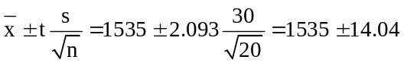,
or between 1520.96 and 1549.04. Using Excel worksheet template tmtint, the computer-assisted
95% confidence interval is shown below.
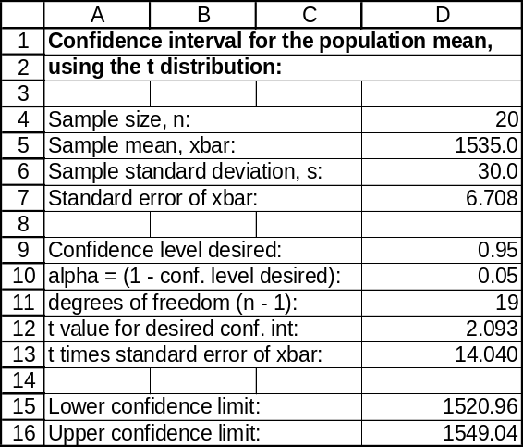

9.38 p/a/m Although the exercise can be done with the pocket calculator and formulas, we will use
the computer and the Estimators workbook that accompanies Data Analysis Plus. As shown below, the 95% confidence interval for the population mean is from 379.97 to 420.03 megabytes per month. We are 95% confident that the population mean is within this interval and, since 350.0 is not within the interval, we would conclude that the population mean could not be 350.0. To that extent, a sample of the same size as this one might seem a little unusual if it had a mean of 350.0.
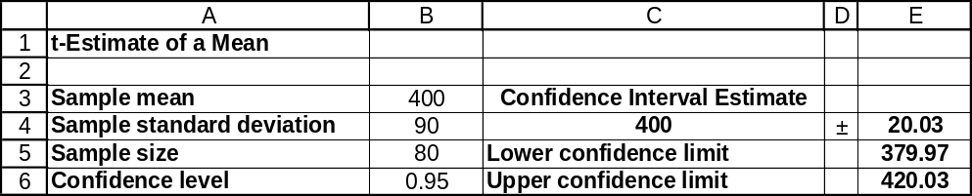

9.39 p/a/m Although the exercise can be done with the pocket calculator and formulas, we will use the computer and the Estimators workbook that accompanies Data Analysis Plus. As shown below, the 98% confidence interval for the population mean is from 17.43 to 21.97 minutes. We are 98% confident that the population mean is within this interval and, since 18.5 minutes is within the interval, we would conclude that the population mean might be 18.5. To that extent, a sample of the same size as this one would not seem unusual if it had a mean of 18.5.
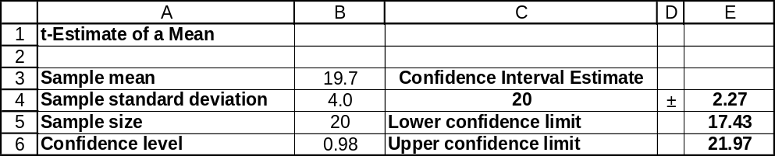

9.40 p/c/m As shown in the Minitab printout below, the 99% confidence interval for the population mean is from $2827.2 to $2996.8. We are 99% confident that the population mean is within this interval and, since $3150 is not within the interval, we would conclude that the population mean could not be $3150. To that extent, a sample of the same size as this one would seem unusual if it had a mean of $3150.

One-Sample T: card_debt
Variable N Mean StDev SE Mean 99% CI
card_debt 200 2912.0 461.3 32.6 (2827.2, 2996.8)

9.41 p/c/m As shown in the Minitab printout below, the 95% confidence interval for the population mean is from 14.646 to 15.354 pairs of shoes. We are 95% confident that the population mean is within this interval and, since 13.2 pairs is not within the interval, we would conclude that the population mean could not be 13.2. To that extent, a sample of the same size as this one might seem unusual if it had a mean of 13.2.

One-Sample T: pairs
Variable N Mean StDev SE Mean 95% CI
pairs 500 15.000 4.030 0.180 (14.646, 15.354)

9.42 d/p/e The approximation is satisfactory whenever np and n(1 - p) are both ≥ 5. However, the approximation is better for large values of n and whenever p is closer to 0.5.

9.43 p/a/m For a confidence level of 95%, z = 1.96. The 95% confidence interval for π is:
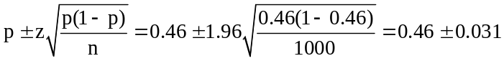, or from 0.429 to 0.491
Using the computer and the Estimators workbook that accompanies Data Analysis Plus:
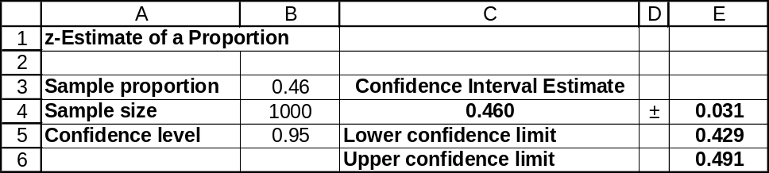

9.44 p/a/m Using the Estimators workbook that accompanies Data Analysis Plus:
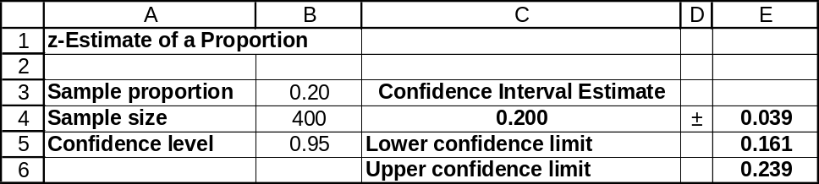

9.45 p/a/m Using the Estimators workbook that accompanies Data Analysis Plus:
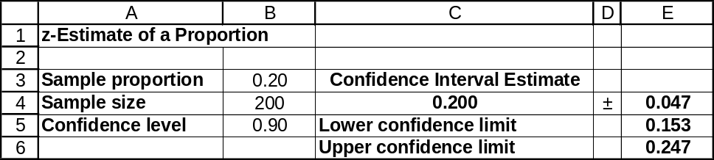
Based on this confidence interval, the 0.50 value falls far above the upper limit, and it would not seem
credible that “over 50% of the students would like a new mascot.”

9.46 p/a/m For a confidence level of 90%, z = 1.645. Since 65 of the 100 invoices sampled were for
customers buying less than $2000 worth of merchandise during the year, p = 0.65. The 90% confidence interval for π = proportion of all sales invoices that were for customers buying less than $2000 worth of merchandise during the year is:
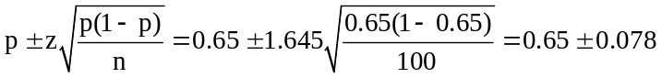, or from 0.572 to 0.728
Using the computer and the Estimators workbook that accompanies Data Analysis Plus:
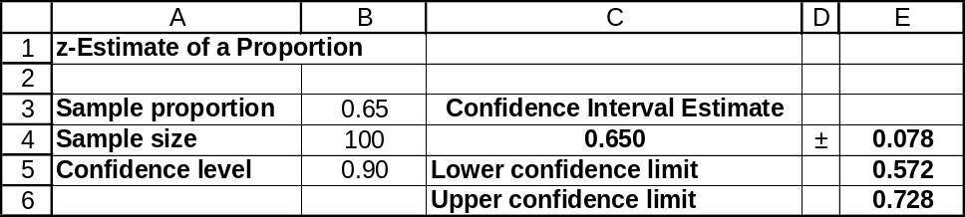

9.47 p/a/m The 95% confidence interval for π is:
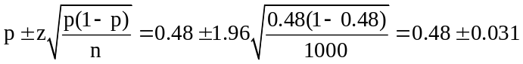, or from 0.449 to 0.511
Using the computer and the Estimators workbook that accompanies Data Analysis Plus:
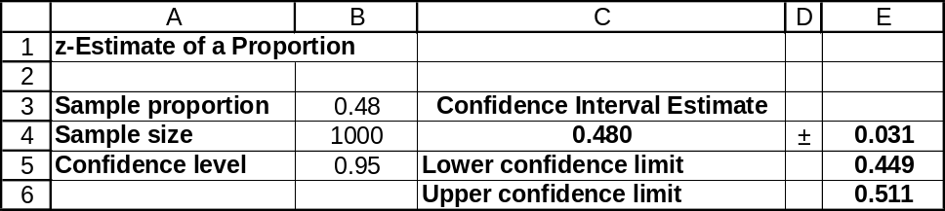

9.48 p/a/m The 90% confidence interval for π is:
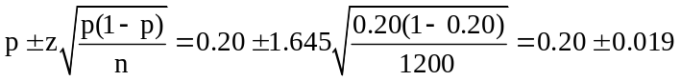, or from 0.181 to 0.219
Using the computer and the Estimators workbook that accompanies Data Analysis Plus:
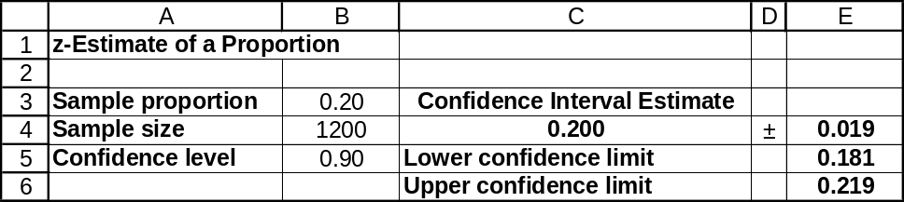

9.49 p/a/m The 95% confidence interval for π is:
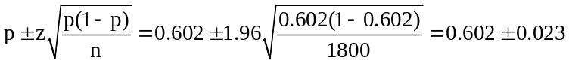, or from 0.579 to 0.625
Using the computer and the Estimators workbook that accompanies Data Analysis Plus:
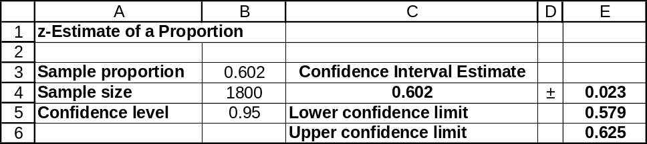

9.50 p/a/d
a. The 99% confidence interval for π is:
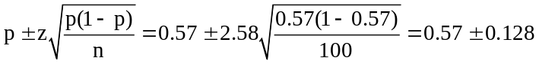, or from 0.442 to 0.698
Using the computer and the Estimators workbook that accompanies Data Analysis Plus:
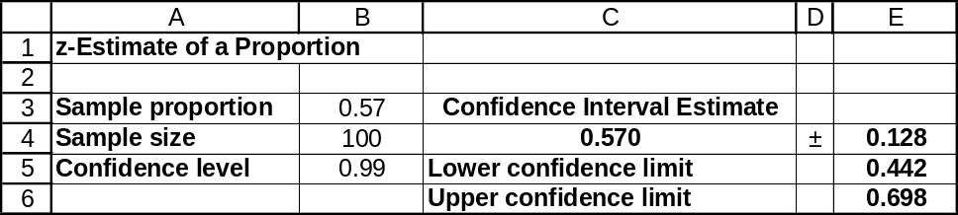

b. It does not appear to be a "sure thing" that the contract will be approved by the union since the 99% confidence interval in part (a) contains values under 0.50. Therefore, less than half of the employees could vote for the contract.

9.51 p/a/d
a. The 99% confidence interval for π is:
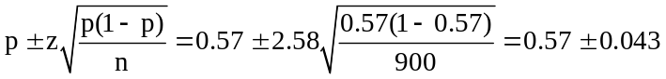, or from 0.527 to 0.613
Using the computer and the Estimators workbook that accompanies Data Analysis Plus:
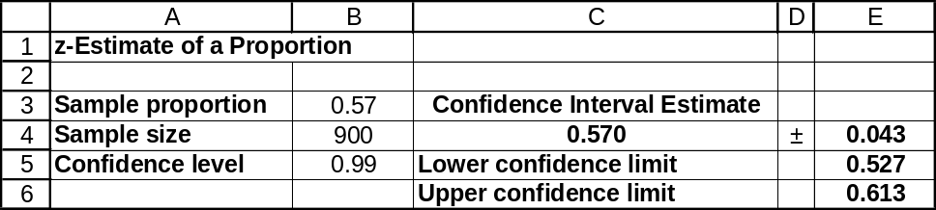
b. It does appear to be a "sure thing" that the contract will be approved by the union since the 99% confidence interval in part (a) only contains values over 0.50. Therefore, it seems that more than half of the employees will be voting for the contract.

9.52 p/a/m The exercise can be done with a pocket calculator and formulas, but we will use the computer and the Estimators workbook that accompanies Data Analysis Plus.
The 90% confidence interval for π is from 0.674 to 0.706.
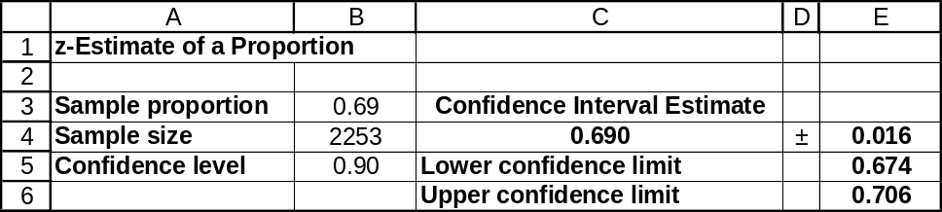

9.53 p/a/m The exercise can be done with a pocket calculator and formulas, but we will use the computer and the Estimators workbook that accompanies Data Analysis Plus.
The 90% confidence interval for π is from 0.649 to 0.711.
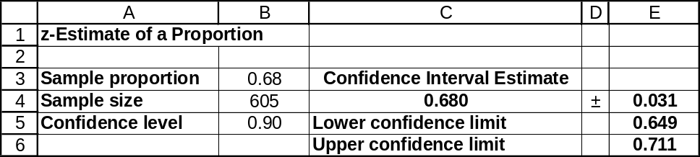

9.54 p/a/m The exercise can be done with a pocket calculator and formulas, but we will use the computer and the Estimators workbook that accompanies Data Analysis Plus.
The 95% confidence interval for π is from 0.726 to 0.774.
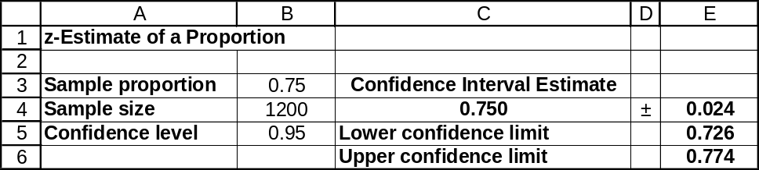

9.55 p/a/m The exercise can be done with a pocket calculator and formulas, but we will use the computer and the Estimators workbook that accompanies Data Analysis Plus.
The 95% confidence interval for π is from 0.566 to 0.634. Ms. McCarthy must get at least 65% of the union vote, but 0.65 exceeds the range of values in the confidence interval. This suggests that she will not obtain the necessary level of union support she needs.
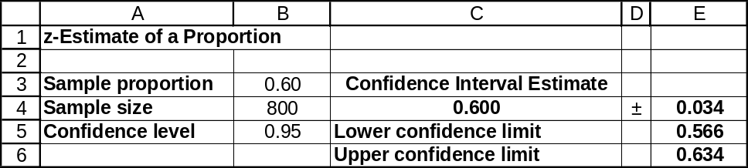

9.56 p/a/m Using Data Analysis Plus, we find that 37.3% of the 300 returns in this sample are because the product “doesn’t work.” The 95% confidence interval for π is from 0.319 to 0.428.
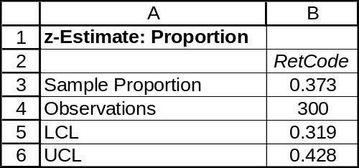

9.57 p/a/m Using Data Analysis Plus, we find that 40.0% of the 200 potential investors in this sample consider themselves to be “someone who enjoys taking risks.” The 99% confidence interval for π is from 0.311 to 0.489.
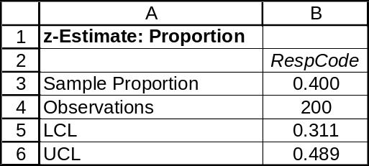

9.58 d/p/m This statement is not correct. The maximum likely error is 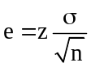. To cut e in half,
we need to quadruple the sample size since we take the square root of n.

9.59 d/p/e One way of estimating the population standard deviation is to use a relatively small-scale pilot study from which the sample standard deviation is used as a point estimate. A second approach is to use the results of a similar study done in the past. We can also estimate σ as 1/6 the approximate range of data values.

9.60 p/a/m For the 95% level of confidence, z = 1.96. The maximum likely error is e = 0.10 and the
estimated process standard deviation is σ = 0.65. The required sample size is:
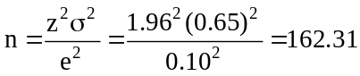, rounded up to 163

9.61 p/a/m For the 99% level of confidence, z = 2.58. The maximum likely error is e = 1.0 and the
estimated population standard deviation is σ = 3.7. The sample size needed is:
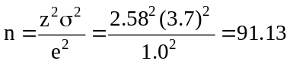, rounded up to 92

9.62 p/a/m For the 95% level of confidence, z = 1.96. The maximum likely error is e = 3.0 and the estimated population standard deviation is σ = 11.2. The number of sets that must be tested is:
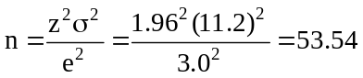, rounded up to 54
We could also obtain the necessary sample size by using Excel worksheet template tmnformu.
Just enter the desired maximum likely error (e = 3.0), estimate of σ (11.2), and the confidence level desired (0.95 for 95%). Excel provides the necessary sample size:
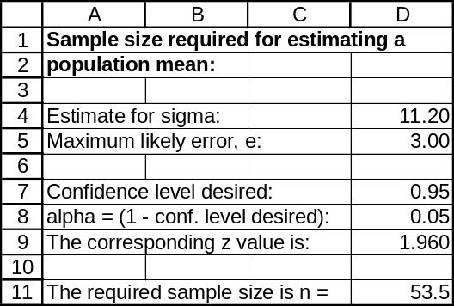

9.63 p/a/m For the 95% level of confidence, z = 1.96. The maximum likely error is e = 0.03,
or 3 percentage points. Assuming the candidate has no idea regarding the actual value of the population proportion, we will use p = 0.5 to calculate the necessary sample size.
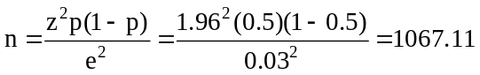, rounded up to 1068

9.64 p/a/d For the 95% level of confidence, z = 1.96. The maximum likely error is e = 0.03.
a. Estimating the population proportion with p = 0.5, the necessary sample size is:
, rounded up to 1068
b. The population proportion would probably be no more than 0.2. Estimating the population proportion with p = 0.2, the necessary sample size is:
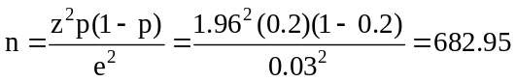, rounded up to 683
We could also obtain the sample sizes in parts (a) and (b) by using Excel worksheet template tmnforpi. Just enter the desired maximum likely error (e = 0.03), estimate of π (0.5 in part a, 0.2 in part b), and the confidence level desired (0.95 for 95%). Excel provides the necessary sample sizes:
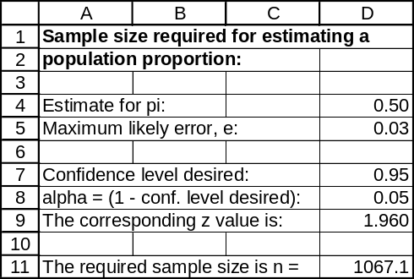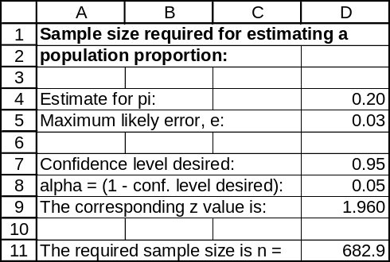

9.65 p/a/m For the 90% level of confidence, z = 1.645. The maximum likely error is e = 0.02 and we will estimate the population proportion with p = 0.15. The number of owners who must be included in the sample is:
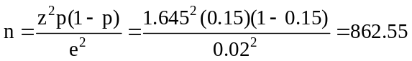, rounded up to 863

9.66 p/a/d The maximum likely error will be greater than 0.02. This is because when p = 0.35 a larger sample size is needed than when p = 0.15.
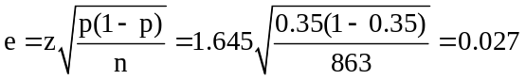, the new maximum likely error

9.67 p/a/d For the 95% level of confidence, z = 1.96. The maximum acceptable error is e = 0.04,
or 4 percentage points. Using p = 0.5 (the most conservative value to use when determining sample size), the sample size used was:
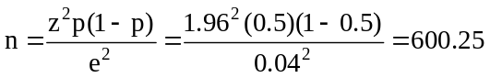, rounded up to 601

9.68 d/p/e The finite population correction should be employed whenever n is at least 5% as large as
the population (n ≥ 0.05N).

9.69 d/p/e
a. The finite population correction will lead to a narrower confidence interval than if an infinite population had been assumed, since the standard error is reduced.
b. The finite population correction will lead to a smaller required sample size than if an infinite population had been assumed, since the standard error is reduced.

9.70 c/a/m The population in this case is finite with σ unknown. Given N = 200, n = 40, = 260,
and s = 80. The 95% confidence interval for μ, with d.f. = n - 1 = 40 - 1 = 39:
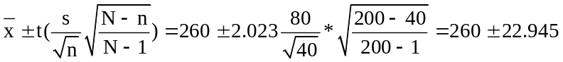, or from 237.055 to 282.945.

9.71 c/a/m The population is finite with N = 1200, n = 600, p = 0.55.
The 95% confidence level for the population proportion, π, is given below.
,
or from 0.522 to 0.578.

The 99% confidence level for the population proportion, π, is given below.
,
or from 0.513 to 0.587.
Each interval includes only values that are greater than 0.500, so it seems likely that the fee
increase will be passed.

9.72 c/a/m The given population is finite. To find a 95% confidence interval for the population mean with N = 100, n = 16, = 12, and s = 4, use the formula below where d.f. = n - 1 = 15:
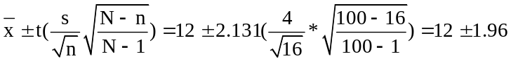, or from 10.04 to 13.96.
Based on the results above, the possibility of exceeding the EPA's recommended limit of 15 parts per billion appears to be rather small. Note that 15 ppb is not within the confidence interval.

9.73 c/a/m Given a population size N = 800, and e = 0.03. Since no estimate has been made regarding the actual population proportion, we will be conservative and use p = 0.5. The sample size necessary to have a 95% confidence level is given below with z = 1.96:
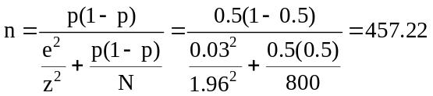, rounded up to 458

9.74 c/a/m For the 99% confidence level, z = 2.58. The maximum likely error is e = 5. The population standard deviation has been estimated as being σ = 40. Applying the finite population formula with
N = 2000, the necessary sample size is:
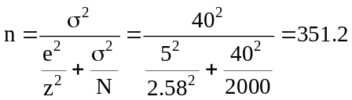, rounded up to 352

9.75 c/a/m For a 95% confidence interval for the population proportion, z = 1.96. Since no estimate has been made regarding the actual population proportion, we will be conservative and use p = 0.5 with
e = 0.03 and N =100.
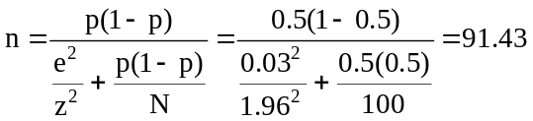, rounded up to 92 senators

9.76 c/a/m For a 90% confidence interval to predict the average maximum speed for a finite population, we are given N = 200 and e = 2. The z-value is 1.645. In order to use the formula, the standard deviation of the population must be estimated. The solution to this exercise will vary depending on your estimation of σ. We will conservatively assume the lowest and highest maximum speeds on interstate highways to be from 55 to 85, and that σ is approximately 1/6 of that difference, or (85 - 55)/6 = 5 mph.
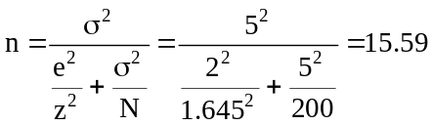, rounded up to 16

9.77 c/a/m To find the number of households surveyed to predict the population proportion of a finite population, we are given N = 2000, level of confidence = 95%, and e = 0.04. Since the population proportion is not known, we shall use the conservative estimate of p = 0.5.
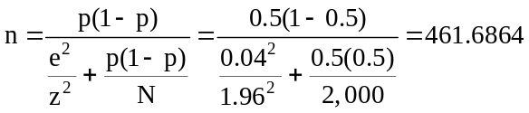, rounded up to 462

9.78 c/a/m To find the number of members to sample in order to estimate the average amount spent
during the first week of the semester, we are given a 99% level of confidence -- yielding a z-value of 2.58, N = 300, and e = 2. In order to use the formula for n, we must estimate the population standard deviation. Your answer may vary depending on your estimate of the standard deviation. A guess might be that the minimum and maximum daily amounts might be $2 and $8, respectively. This leads to a weekly minimum and maximum of $14 and $56, respectively. Estimating σ as 1/6 of this distance, our estimate is σ = (56 - 14)/6 = $7.
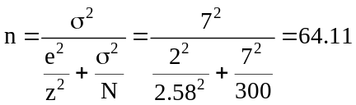, rounded up to 65

9.79 p/a/m For the 99% confidence level, z = 2.58. The maximum likely error is e = 0.01, or 1 percentage point, and we will estimate the population proportion with p = 0.05. Applying the finite population formula with N = 2000, the necessary sample size is:
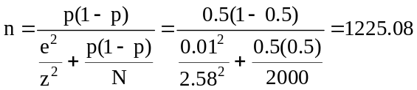, rounded up to 1226

CHAPTER EXERCISES
9.80 p/a/m Since σ is known, we will use the standard normal distribution. For a confidence level
of 99%, z = 2.58. The 99% confidence interval for μ is:
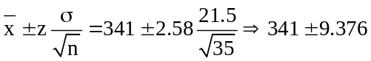, or from 331.624 to 350.376
We have 99% confidence that the true mean breaking strength of briefcases produced today is between 331.624 and 350.376 pounds. We can also obtain this confidence interval by using Excel worksheet template tmzint. Enter the values for n, , σ, and the desired confidence level (0.99 for 99%).
Excel then provides the lower and upper confidence limits.
The Excel limits differ slightly from the ones we calculated. This is because our z value was from the standard normal table in the text and z = 2.58 had been rounded to two decimal places.
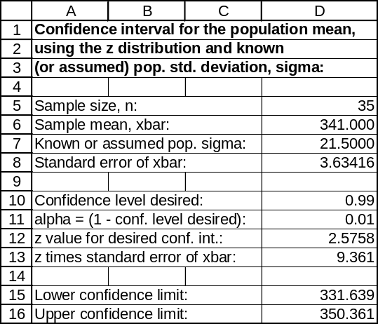

9.81 c/a/d Since the researchers are working independently,
P(neither of the confidence intervals include μ) =
P(Researcher 1's interval does not contain μ) x P(Researcher 2's interval does not contain μ)
= (1 - 0.90)(1 - 0.90) = 0.01

9.82 c/c/m Using Minitab, we find the confidence intervals shown below:

One-Sample T: Minutes
Variable N Mean StDev SE Mean 90.0 % CI
Minutes 15 29.87 4.77 1.23 ( 27.70, 32.04)

One-Sample T: Minutes
Variable N Mean StDev SE Mean 95.0 % CI
Minutes 15 29.87 4.77 1.23 ( 27.23, 32.52)

9.83 p/a/d Since σ is known, we will use the standard normal distribution. For a confidence level of 95%, z = 1.96. The 95% confidence interval for μ is:
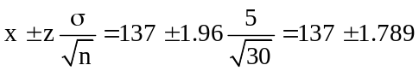, or from 135.211 to 138.789
We have 95% confidence that the current process mean is between 135.211 and 138.789 lbs.-ft.
Since the desired process average of 135 lbs.-ft. is not in the 95% confidence interval found above,
the machine may be in need of adjustment.

9.84 p/a/m For the 95% level of confidence, z = 1.96. The maximum likely error is e = 0.05,
or 5 percentage points. Since no estimate has been made regarding the actual population proportion,
we will be conservative and use p = 0.5. The number of TV households needed in the sample is:
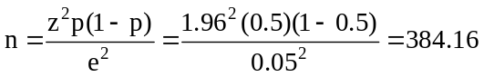, rounded up to 385.

9.85 p/a/m From exercise 9.84, z = 1.96 and e = 0.05. We will estimate the population proportion with
p = 0.20. The number of TV households needed in the sample now is:
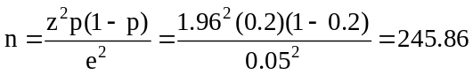, rounded up to 246.

The sample sizes in exercises 9.84 and 9.85 can also be obtained using Excel worksheet template tmnforpi. Enter the estimate for π, the maximum likely error desired, and the confidence level
(0.95 for 95%), and Excel computes the necessary sample size:
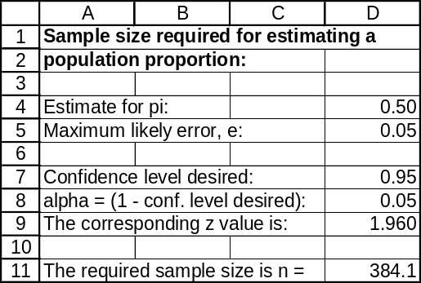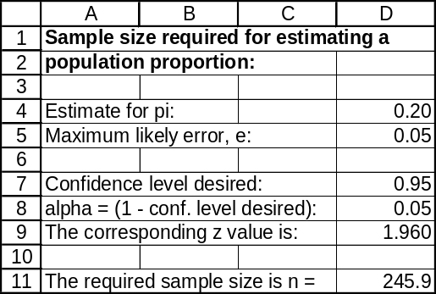

9.86 p/a/m
a. For a confidence level of 95%, z = 1.96. The 95% confidence interval for π is:
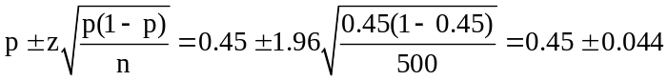, or from 0.406 to 0.494
We have 95% confidence that the proportion of U.S. adults who consider lounging at the beach to be their "dream vacation" is between 0.406 and 0.494.
b. For a confidence level of 99%, z = 2.58. The 99% confidence interval for π is:
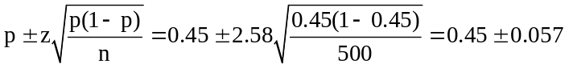, or from 0.393 to 0.507
We have 99% confidence that the proportion of U.S. adults who consider lounging at the beach to be their "dream vacation" is between 0.393 and 0.507.

These confidence intervals can also be obtained using Excel worksheet template tmpint. Enter the values for p, n, the maximum likely error desired, and the confidence level (0.95 for 95%, 0.99 for 99%), and Excel provides the confidence limits:
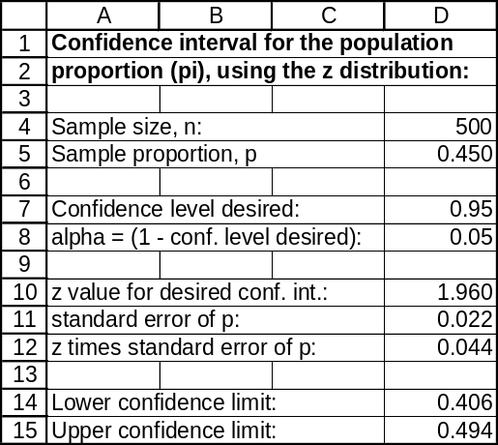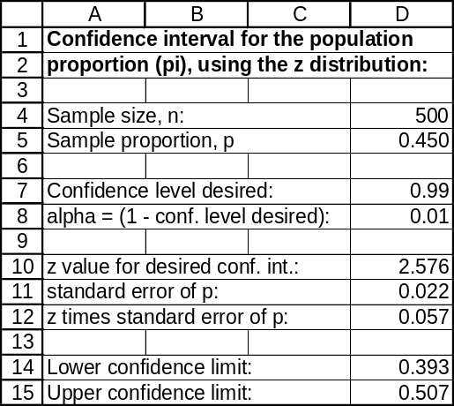

9.87 c/c/m Using Minitab, we find the confidence intervals shown below:

One-Sample T: Income
Variable N Mean StDev SE Mean 90.0 % CI
Income 30 47.43 8.14 1.49 ( 44.91, 49.96)

One-Sample T: Income
Variable N Mean StDev SE Mean 95.0 % CI
Income 30 47.43 8.14 1.49 ( 44.39, 50.47)

9.88 p/a/d Let x = number of confidence intervals that do not contain the population mean, x is binomial with n = 20 and π = 0.10. Using the table of cumulative binomial probabilities,
P(x ≥ 2) = 1 - P(x ≤ 1) = 1 - 0.3917 = 0.6083.

9.89 p/a/m For the 90% confidence level, z = 1.645. The maximum likely error is e = 0.03, or 3 percentage points. Since no estimate has been made regarding the actual population proportion, we will be conservative and use p = 0.5. Applying the finite population formula with N = 904, the number of franchises needed in the sample is:
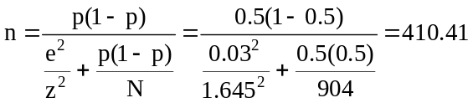, rounded up to 411

9.90 p/a/m From exercise 9.89, we will use a sample size of 411. For the 95% level of confidence,
z = 1.96. Since the sample is more than 5% as large as the population of N = 904, the 95% confidence interval for π is:
or from 0.243 to 0.307.

9.91 p/a/d For the 90% level of confidence, z = 1.645. The maximum likely error is e = 0.03.
Using p = 0.5, 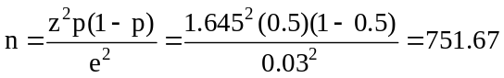, rounded up to 752
Using p = 0.3, 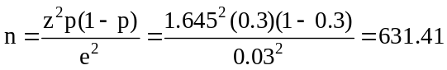, rounded up to 632
The new graduate just saved the company (752 - 632) x 10 = $1200 in interview costs.
9.92 p/a/m For a confidence level of 95%, z = 1.96. Since the sample of n = 100 is less than 5% as large as the population of N = 10,000, we don't need to use the finite population correction.
The 95% confidence interval for π is:
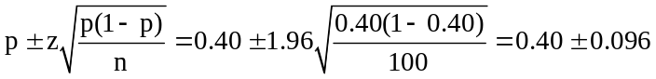, or from 0.304 to 0.496

9.93 p/a/m
For a confidence level of 95%, z = 1.96. The 95% confidence interval for π is:
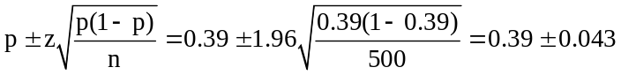, or from 0.347 to 0.433
The maximum likely error is 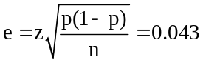. If we use p = 0.39 to estimate π, we will have 95% confidence that we are within 0.043 of the true population proportion.
For a confidence level of 99%, z = 2.58. The 99% confidence interval for π is:
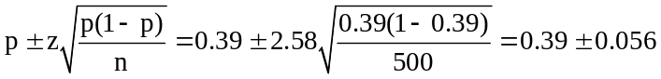, or from 0.334 to 0.446
The maximum likely error is 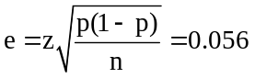. If we use p = 0.39 to estimate π, we will have 99% confidence that we are within 0.056 of the true population proportion.

9.94 d/p/d Since σ is known, we will use the normal distribution. For a confidence level of 95%,
z = 1.96. For a confidence level of 99%, z = 2.58.
The width of a confidence interval for μ is 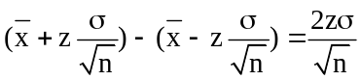, so the width is proportional to the value of z. If the width of a 95% interval is y, then the width of a 99% interval will be y(2.58/1.96), or 1.316y.

9.95 p/a/d For the 99% level of confidence, z = 2.58. The maximum likely error is e = 0.02
(2 percentage points). If we make no estimate regarding the actual population proportion, we can be conservative and use p = 0.5. The recommended sample size would be:
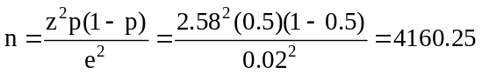, rounded up to 4161
Persons who are aware that Count Chocula is a kid's cereal, and that senior citizens don't tend to consume the product, might want to use a lower estimate, such as p = 0.10. In this case, we would end up with a recommended sample size of just 1498.

9.96 p/a/d For a confidence level of 95%, z = 1.96. The sample proportion is p = 32/121 = 0.264.
The 95% confidence interval for π is:
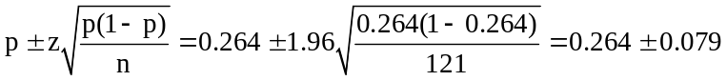, or from 0.185 to 0.343
With 8(60) = 480 minutes in the workday, we are 95% confident the employee spends between 0.185(480) = 88.80 and 0.343(480) = 164.64 minutes talking on the phone during an average day.

9.97 p/a/d For the 90% level of confidence, z = 1.645. The maximum likely error is e = 0.03, or 3 percentage points. We will estimate the population proportion with p = 0.4, the part of our range that is closest to the most conservative possible estimate, 0.5. The needed sample size is:
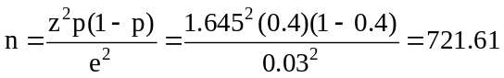, rounded up to 722.

9.98 p/a/m With n = 1320 and p = 0.24, the 90% confidence interval for π is:
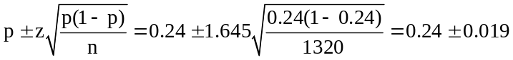, or from 0.221 to 0.259
An alternative approach is to use Excel worksheet template tmpint. Just enter the sample size,
the sample proportion, and the desired confidence level:
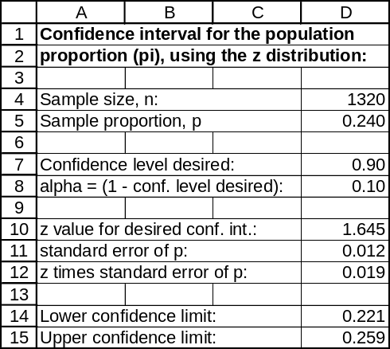

9.99 p/a/m For the 95% level of confidence, z = 1.96. The maximum acceptable error is e = 0.03, or 3 percentage points. Since no estimate has been made regarding the actual population proportion, we will be conservative and use p = 0.5. The recommended sample size is:
, rounded up to 1068.
An alternative approach is to use Excel worksheet template tmnforpi. Just enter the estimate (in this case, 0.5), the maximum likely error desired (0.03), and the desired confidence level (0.95 for 95%):

9.100 p/a/d To calculate the necessary sample size, the formula used is 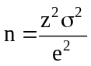.
If e is reduced to one-fourth of that originally specified, the new n must be 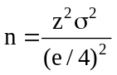.
Therefore, the necessary sample size will be 16 times as large as the original calculation.
The sample size needed is 16 x 100 = 1600.

9.101 p/a/m For the 95% confidence level, z = 1.96. The maximum likely error is e = 0.01. Since no
estimate has been made regarding the actual population proportion, we will be conservative and use
p = 0.5. Applying the finite population formula with a population size of N = 1254, the number
of companies that must be sampled is:
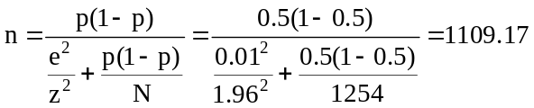, rounded up to 1110

9.102 p/a/m From exercise 9.101, we will use a sample of size 1110, For a level of confidence of 95%,
z = 1.96. Since the sample is more than 5% as large as the population of N = 1254, the 95% confidence interval for π is:
or from 0.3803 to 0.3997. We are 95% confident that the population proportion is between 0.3803 and 0.3997.

9.103 p/a/m For the 99% confidence level, z = 2.58. The maximum likely error is e = 0.02. Since no estimate has been made regarding the actual population proportion, we will be conservative and use
p = 0.5. Applying the finite population formula with N = 36,600, the necessary sample size is:
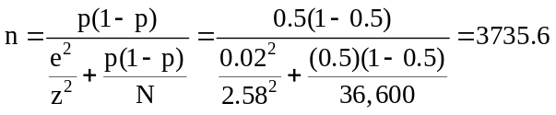, rounded up to 3736

9.104 c/a/m The tensile strength is given to be normal with a standard deviation of 20, and we want to find the size of the sample necessary to compute the 90% confidence interval for the population mean with a maximum likely error, e = 5. By formula, the necessary sample size is:
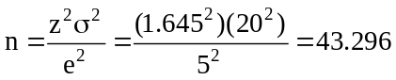, rounded up to 44
As an alternative, we can use Excel worksheet template tmnformu. Just enter the desired confidence level (0.90 for 95%), the maximum likely error desired (5), and our estimate of σ (20):
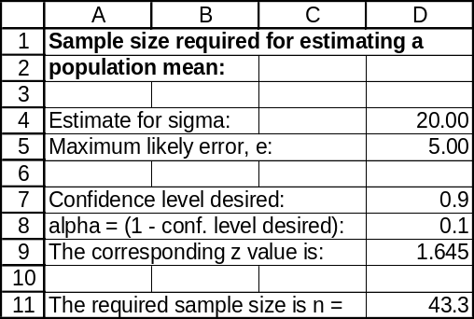

9.105 p/a/m With n = 1000 and p = 0.40, the 90% and 95% confidence intervals can be determined by computing 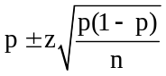with z = 1.645 and z = 1.96, respectively.
Using the Estimators workbook that accompanies Data Analysis Plus, these confidence intervals are shown below as 0.375 to 0.425 and 0.370 to 0.430, respectively.
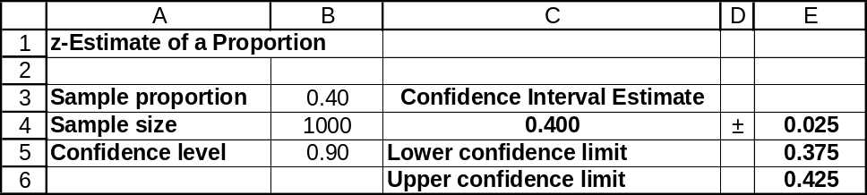
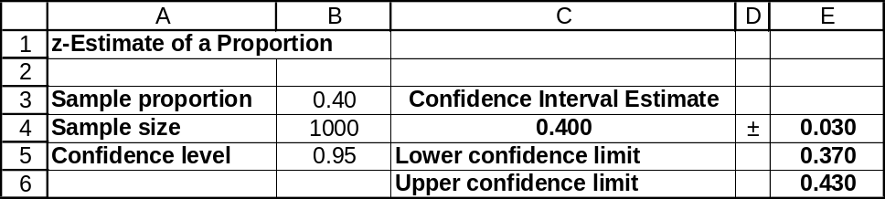

9.106 d/p/d The maximum likely error is less than that originally specified. The closer the value of π is to 0.5, the larger the sample size that will be needed. Therefore, we took a larger sample than was needed. This would make the maximum likely error smaller than what was specified.

9.107 p/a/d For the 95% confidence level, z = 1.96. The sample proportion is p = 12/300 = 0.04.
Since the sample is less than 5% as large as the population of N = 8000, we do not need to use the finite population correction. The 95% confidence interval for π is:
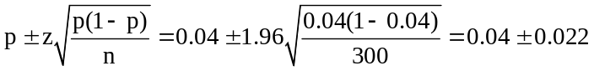, or from 0.018 to 0.062
We can also obtain the confidence interval by using the Estimators workbook that accompanies
Data Analysis Plus.
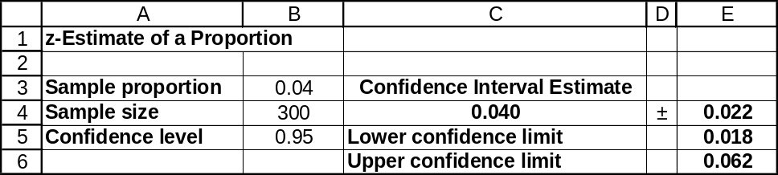

We have 95% confidence that the proportion of the boards that fall outside the specifications is between 0.018 and 0.062. Although 0.03 is in the interval, there are also values in the interval that are more than 0.03. It is possible that the supplier's claim is correct but it is also possible that the supplier's claim is not correct.

9.108 p/a/m The exercise can be done with a pocket calculator and formulas, but we will use the computer and the tmtint worksheet. The 99% confidence interval for the population mean is from 17.038 to 17.362 hours per week.
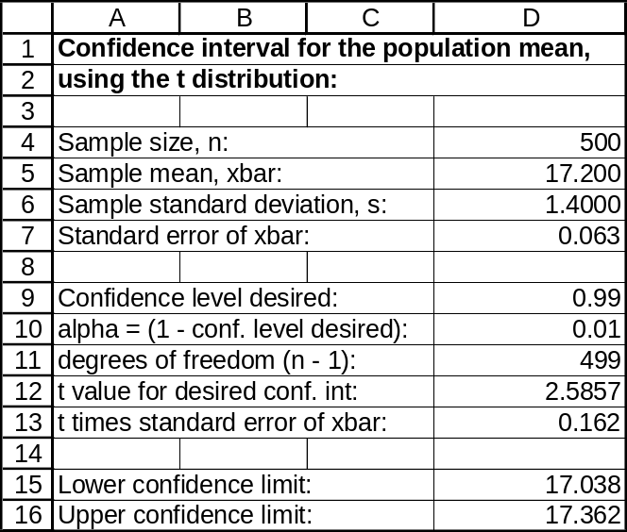

9.109 p/c/m Using Data Analysis Plus, the 95% confidence interval for the population mean is from $95.56 to $98.45. The Minitab counterpart is shown below the Excel printout.
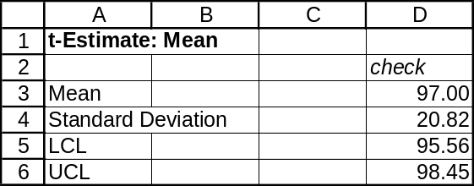

One-Sample T: check
Variable N Mean StDev SE Mean 95% CI
check 800 97.000 20.824 0.736 (95.555, 98.446)

9.110 p/c/m Using Data Analysis Plus, the 90% confidence interval for the population mean is from $4452.86 to $4697.07. The Minitab counterpart is shown below the Excel printout.
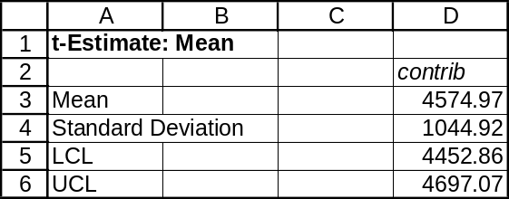

One-Sample T: contrib
Variable N Mean StDev SE Mean 90% CI
contrib 200 4575.0 1044.9 73.9 (4452.9, 4697.1)

We find that $4388 is less than the range of values within the confidence interval for this legislative district. This suggests that the population mean deduction for gifts to charity in this legislative district is some value other than $4388, and we conclude that this district is not typical of the nation as a whole. These taxpayers seem to be more generous than the national average.

9.111 p/c/m Using Data Analysis Plus, the 95% confidence interval for the population mean is from 64.719 to 68.301 mph. The Minitab counterpart is shown below the Excel printout.
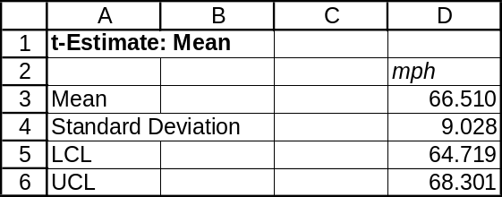

One-Sample T: mph
Variable N Mean StDev SE Mean 95% CI
mph 100 66.510 9.028 0.903 (64.719, 68.301)

We find that 70.0 mph exceeds the range of values described by the confidence interval. This suggests that the population mean mph on this section of highway is some value less than 70 mph. The Federal highway funds are not in danger.

INTEGRATED CASES

THORNDIKE SPORTS EQUIPMENT (THORNDIKE VIDEO UNIT FOUR)

The mean and standard deviation of the sample are 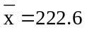 and s = 6.621.
Since σ is unknown, we will use the t distribution. In order to be conservative, we will find a 99% confidence interval for μ. For a confidence level of 99%, the right-tail area of interest is
(1 - 0.99)/2 = 0.005 with d.f. = n - 1 = 20 - 1 = 19. Referring to the 0.005 column and d.f. = 19 row
of the t table, t = 2.861. The 99% confidence interval for μ is:
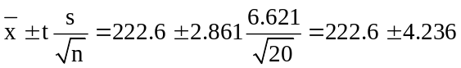, or from 218.364 to 226.836

We have 99% confidence that the population mean breaking strength of the racquets is between 218.364 and 226.836 pounds. If Ted wants to be very conservative in estimating the population mean breaking strengths of the racquets, he might want to use the lower limit of the confidence interval in the ads (218.364 pounds).
Instead of using a pocket calculator and formulas, we can use the computer. The printouts below were obtained using Data Analysis Plus and Minitab. Subject to very small differences due to rounding in the use of the pocket calculator and printed tables, these results correspond closely to those calculated above.
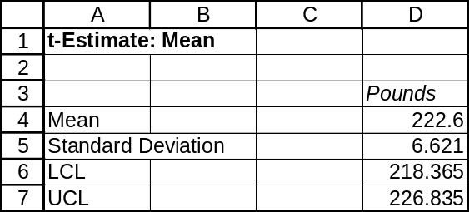

One-Sample T: Pounds
Variable N Mean StDev SE Mean 99% CI
Pounds 20 222.600 6.621 1.480 (218.365, 226.835)

SPRINGDALE SHOPPING SURVEY

1. General attitude toward each of the three shopping areas.

a. Point estimate and 95% confidence interval for variable 7, attitude toward Springdale Mall.
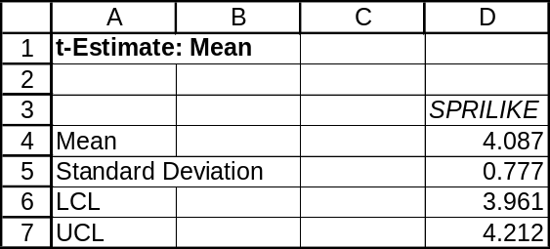

One-Sample T: SPRILIKE
Variable N Mean StDev SE Mean 95% CI
SPRILIKE 150 4.08667 0.77664 0.06341 (3.96136, 4.21197)

Using Data Analysis Plus, the point estimate of the mean attitude toward Springdale Mall is seen above as 4.087. The maximum likely error in the point estimate of the population mean attitude toward Springdale Mall can be calculated as half the difference between the upper and lower limits of the confidence interval, or (4.212 - 3.961)/2 = 0.168.

b. Mean and 95% confidence interval for variable 8, attitude toward Downtown.
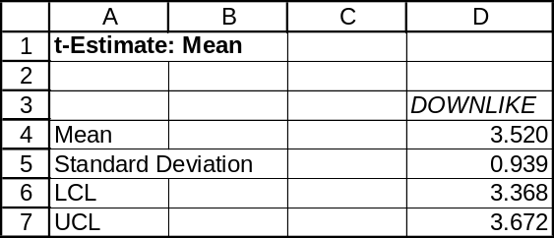

One-Sample T: DOWNLIKE
Variable N Mean StDev SE Mean 95% CI
DOWNLIKE 150 3.52000 0.93923 0.07669 (3.36846, 3.67154)

Using Data Analysis Plus, the point estimate of the mean attitude toward Downtown is seen above as 3.520. The maximum likely error in the point estimate of the population mean attitude toward Downtown can be calculated as half the difference between the upper and lower limits of the confidence interval, or (3.672 - 3.368)/2 = 0.152.

Mean and 95% confidence interval for variable 9, attitude toward West Mall.
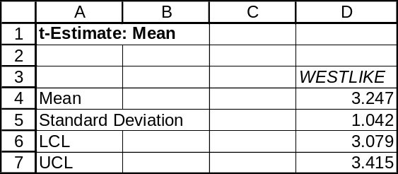

One-Sample T: WESTLIKE
Variable N Mean StDev SE Mean 95% CI
WESTLIKE 150 3.24667 1.04230 0.08510 (3.07850, 3.41483)

Using Data Analysis Plus, the point estimate of the mean attitude toward West Mall is seen above as 3.247. The maximum likely error in the point estimate of the population mean attitude toward West Mall can be calculated as half the difference between the upper and lower limits of the confidence interval, or (3.415 - 3.079)/2 = 0.168.

2. Sample proportion and 95% confidence interval for variable 26 (gender of respondent), proportion who are male.
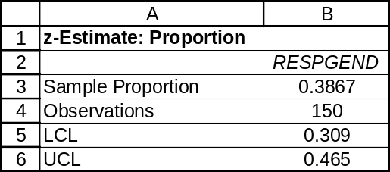

Using Data Analysis Plus, the point estimate of the population proportion who are male is seen above as 0.3867. The maximum likely error in the point estimate of the population proportion of males can be calculated as half the difference between the upper and lower limits of the confidence interval, or (0.465 - 0.309)/2 = 0.078.

3. Sample proportion and 95% confidence interval for variable 28 (marital status of respondent), proportion who are “single or other.”
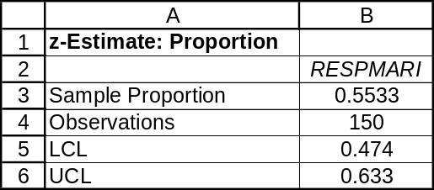

Using Data Analysis Plus, the point estimate of the population proportion who are “single or other” is seen above as 0.5533. The maximum likely error in the point estimate of the population proportion who are “single or other” can be calculated as half the difference between the upper and lower limits of the confidence interval, or (0.633 - 0.474)/2 = 0.080.

